

**INDUSTRIAL PROJECT REPORT**

**“Static Int Educare”**

**Department of Computer**

**Engineering**

**Submitted By:** Prem Rajendra Mane **Enrollment Number**: 2205220361

**Mentor:** Mr. Kashif sheikh

**CERTIFICATE**



**MAHARASHTRA STATE BOARD OF**

**TECHNICAL EDUCATION**

This is to certify that the following group of students **Roll no. 40** of **5th semester** of **Diploma in Computer Engineering** of institute, **Thakur Polytechnic (Code:0522)** have completed teamwork satisfactorily in subject- Industrial Training (ITR-22057) for the academic year 2024 –2025 as prescribed in the curriculum.

Seal

of

Institute

Place: Mumbai Enrolment No:2205220361

Date:

Seat Number:1287145

|  |  |  |
| --- | --- | --- |
| **Mentor** | **Head Of The Department** | **Principal** |
| **Mr.Kashif sheikh** | **Ms. Vaishali Rane** | **Dr. S.M.Ganechari** |

# ABSTRACT

Static Int Educare is a Startup Company trying to reduce the skill gap in the industry of the new developers. After students complete their Diploma or Degree, they generally have no idea about the new technologies in the industry due to which it becomes difficult to adapt in the industry.

Static Int Educare has taught us various technologies such as JavaScript, React, Node JS, Express, MongoDB, Python, Git Hub and Soft Skills.

We not only learned the language and technologies but also how they work behind the hood, their uses in industries and their history.

# ACKNOWLEDGEMENT

This acknowledgment transcends the reality of formality when we would like to express deep gratitude and respect to all those people behind the screen who guided, inspired and helped us for the completion of our project work.

This project would add as an asset to our academic profile. We express our sincere gratitude to our respectful Principal Dr. S.M. Ganechari for enabling us to make use of laboratory and library facilities liberally, that helped us a long way in carrying out our project work successfully.

We consider ourselves lucky enough to get such a good project. This project would add as an asset to our academic profile. We express our gratitude to the help of the Head of the Department of Computer Engineering, Ms. Vaishali Rane, for her constant supervision, guidance and co-operation throughout the project and we would like to express our thankfulness to our project guide, Mr. Kashif Sheikh for his constant motivation and valuable help through the project work. We extend our sincere gratitude to our parents who have encouraged us with their blessings to do this project successfully.

Finally, we would like to thank all our friends, all the teaching and non- teaching staff members of the CO Department, for all the timely help, ideas and encouragement which helped throughout in the completion of project.

# CONTENT PAGE

**Chapter 1:**

Organizational Structure of Organization and General Layout.

**Chapter 2:**

Introduction of Organization.

**Chapter 3:**

Types of major equipment used in Organization with their specification, approximate cost and specific use and their routine maintenance.

**Chapter 4:**

Manufacturing Processed along with production planning and control methods.

**Chapter 5:**

Testing of raw materials, components and finished products along with quality assurance procedures.

**Chapter 6:**

Major material handling product.

**Chapter 7:**

Safety procedures followed and safety gear used.

**Chapter 8:**

Particulars of Practical Experiences in Organization if any in Production / Assembly / Testing / Maintenance.

**Chapter 9:**

Short report descriptions of the project.

**Chapter 10:**

Special/Challenging experiences encountered during the Training.

**Organizational Structure of Organization and General Layout.**

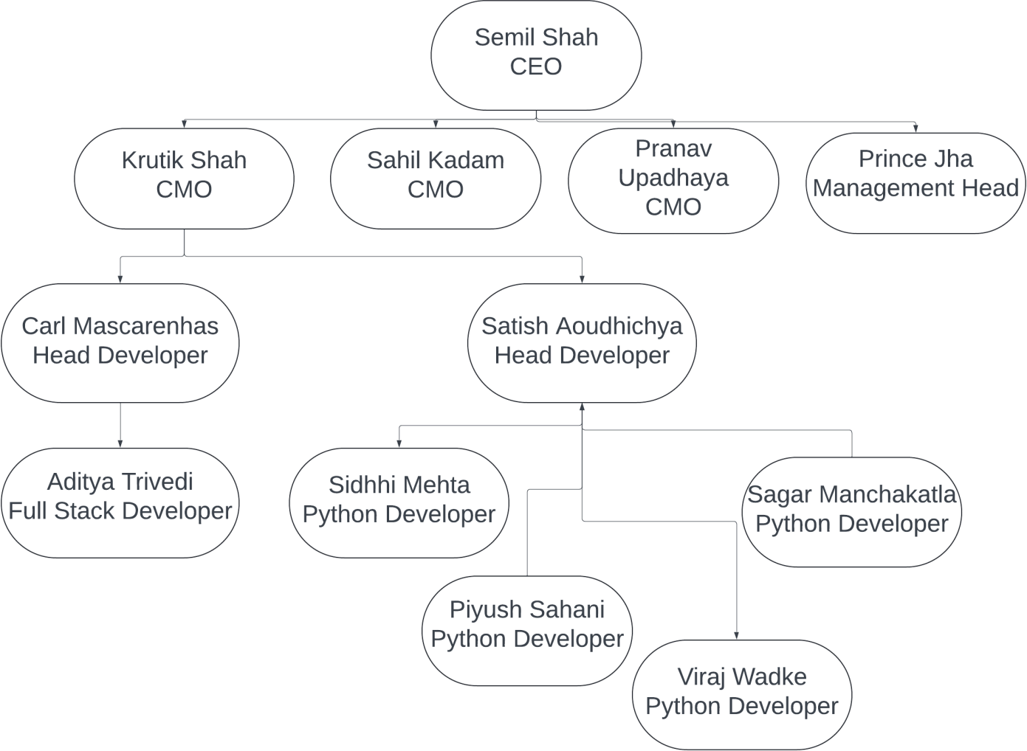

**Introduction of Organization.**

**Vision:**

To change the Idea and approach of the students towards the competitive industry so that they have a sustainable and bright future.

**Mission:**

Discover, share, and implement effective modern technology with enhanced learning practices that promote active, collaborative, and authentic learning. Create a project-based learning environment for students to develop foundational skills and knowledge for the 21st century workplace.

**Location:**

Mumbai, Maharashtra

Number of employees: 17

Turn Over: Rs. 4, 50,000

**Types of major equipment used in Organization with their specification, approximate cost and specific use and their routine maintenance.**

**Major Machines:**

1. Macbook Pro M2
2. Dell Inspiron 3593
3. HP notebook
4. Dell Inspiron 5570 5. Asus r558u
5. Asus vivo book 14
6. Acer swift
7. HP Pavilion

**Preventive and Breakdown Maintenance:**

Until now the company hasn’t seen issues of breakdown but there is regular maintenance of the machine and it is outsourced to KK technologies

**Manufacturing Processes along with production planning and control methods**

The Start-up believes in building sustainable and adaptive software with the help of Agile methodology of software development.

Static.int uses the Scrum framework for the development of software. With this the company also assures that the interns are made to learn the technology they are working with the help of project-based learning.

The Scrum framework prioritizes the convenience of the customers to provide them with software which can be provided with added features down the line of the development process.

**Testing of raw materials, components and finished products along with quality assurance procedures.**

**Testing and quality assurance:**

The company uses modern Automated testing tools for the software testing purpose some with which we have worked are as follows:

1. XENU’S LINK SLEUTH
2. CLIP2NET

## Major material handling product

**VS Code:**

Leveraging the latest version of VS Code, you gain access to a powerful source code editor equipped with an intuitive interface, seamless Git integration, and extensive extensions support. It optimizes coding experiences, streamlines version control, and enhances productivity, making it a valuable and indispensable tool for modern software development endeavors.

**Python:**

Leveraging the latest version of Python, you harness a versatile and readable programming language. Python's extensive library ecosystem enables the development of scalable backend systems, web apps, and automation scripts. Its clear syntax and ease of use facilitate rapid development, making it an excellent choice for various projects, from web development to data analysis and machine learning.

**JavaScript:**

Leveraging the latest version of JavaScript, you exploit a versatile, high-level programming language widely used for web development. It enables interactive and dynamic content on websites, allowing for enhanced user experiences. JavaScript treats functions as first-class citizens, enabling them to be assigned to variables, passed as arguments, and returned from other functions. It is also event- driven, meaning it can respond to user actions like clicks, key presses, and other events in real time. These features, combined with its versatility and robust ecosystem of frameworks and libraries, make JavaScript an essential tool for modern web development.

**React:**

By combining the latest version of React.js with other cutting-edge tools, you create dynamic and visually appealing user interfaces. React.js, a popular JavaScript library, empowers you to build reusable UI components for efficient and maintainable code. Its virtual DOM optimizes updating the user interface. developers aiming to deliver exceptiona performance by efficiently updating the user interface. With React.js, you craft modern and responsive web applications, benefiting from its robust ecosystem of libraries and community support. This framework allows for seamless integration with other technologies, making it a preferred choice for developers aiming to deliver exceptional user experience.

**Node.JS:**

Node.js is a runtime environment that allows developers to execute JavaScript code on the server side, outside of a web browser. Built on the V8 JavaScript engine, Node.js is designed for building scalable and efficient network applications. It employs an event-driven, non-blocking I/O model, which makes it particularly well-suited for handling multiple concurrent connections with high throughput and low latency. This architecture enables developers to use JavaScript for both client-side and server-side development, promoting code reuse and a unified programming language across the entire application stack. With a rich ecosystem of libraries and modules available through npm (Node Package Manager), Node.js has become a popular choice for developing web servers, APIs, real-time applications, and microservices.

**Express:**

Express is a minimal and flexible Node.js web application framework that provides a robust set of features for building web and mobile applications. As a lightweight framework, it simplifies the development process by providing a thin layer of fundamental web application features, without obscuring Node.js's core functionalities. Express offers a variety of built-in middleware functions to handle different aspects of HTTP requests and responses, such as routing, authentication, and error handling. Its simplicity and extensibility make it easy to integrate with other modules and tools, enabling developers to create complex, high- performance web applications and APIs with minimal effort. With its wide adoption and strong community support, Express is a cornerstone of the Node.js ecosystem, commonly used in conjunction with other technologies like MongoDB and Angular to build full-stack JavaScript applications.

**MongoDB:** MongoDB is a popular open-source NoSQL database that stores data in a flexible, JSON-like format called BSON (Binary JSON). Unlike traditional relational databases, MongoDB uses a document-oriented data model, allowing for the storage of complex and hierarchical data structures without the need for a predefined schema. MongoDB supports horizontal scaling through sharding, which distributes data across multiple servers to handle large-scale data and high- traffic applications efficiently. With its ease of use, scalability, and flexibility,

MongoDB has become a preferred database solution for developers

**CHAPTER 7**

**Safety procedures followed and safety gear used.**

**Safety Practices:**

The Company has top notch safety practices regarding the data and software. They use premium IDE's and data storage mediums so to avoid data corruption they also use Microsoft Azure and GitHub for data backup which is being done periodically.

**CHAPTER 8**

**Particulars of Practical Experiences in Organization if any in Production / Assembly / Testing / Maintenance**

**Preventive and Breakdown Maintenance:**

Until now the company hasn’t seen issues of breakdown but there is regular maintenance of the machine.

**Safety Practices:**

The Company has top notch safety practices regarding the data and software. They use premium IDE's and data storage mediums so to avoid data corruption they also use Microsoft Azure and GitHub for data backup which is being done periodically.

**Short report descriptions of the project**

**CHAPTER 9**

**Assignment Repository:**

|  |  |
| --- | --- |
|  | **PYTHON** |
| **1** | Basic Calculator and Temperature Conversation |
| **2** | Library Management System |
| **3** | Vehicle Rental System |
| **4** | Feedback System using File Handling |
| **5** | Inventory Management System for a Grocery Store with File and Exception Handling |
| **6** | Restaurant Management System |
| **7** | Data Cleaning and Analysis of COVID-19 Dataset |
| **8** | Data Visualization of COVID-19 Dataset |
|  | **JAVASCRIPT** |
| **1** | Basic Concept Of JavaScript |
| **2** | Implementation of Scope of Variables and Blocks |
| **3** | Array implementation and its method |
| **4** | Implementation of Object and String methods |
| **5** | Implementation of Closure and Prototypes |
|  | **NODE.JS** |
|  | **REACT.JS** |
|  | **SOFT SKILLS** |
| **1** | Formal Email writing and E-signature Attach |
| **2** | Resume Building (Google Docs) |
| **3** | Resume Building (Canva) |
|  | **PROJECT DEVELOPMENT** |
| 1 | Python Project – Data Visualization on Sales Data using Matplotlib and Streamlit |
| 2 | Node JS and React Project – |

**PYTHON ASSIGNMENTS**

**Assignment 1. Basic Calculator and Temperature Conversion**

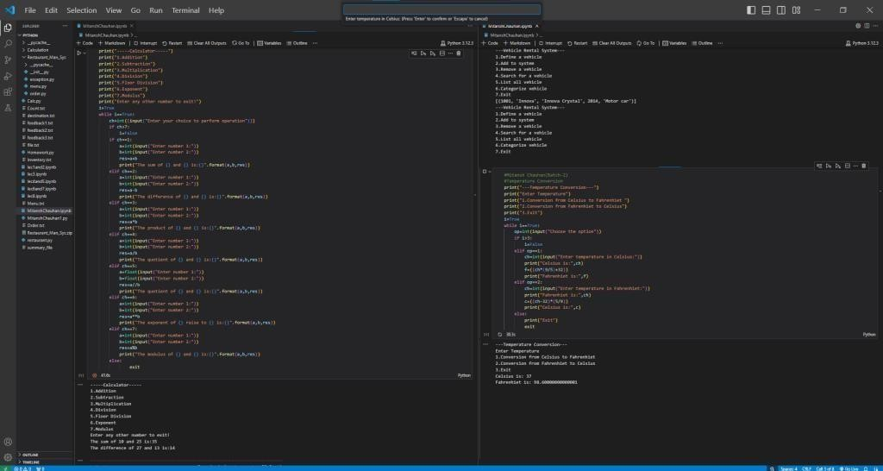

**Assignment 2. Library Management System**

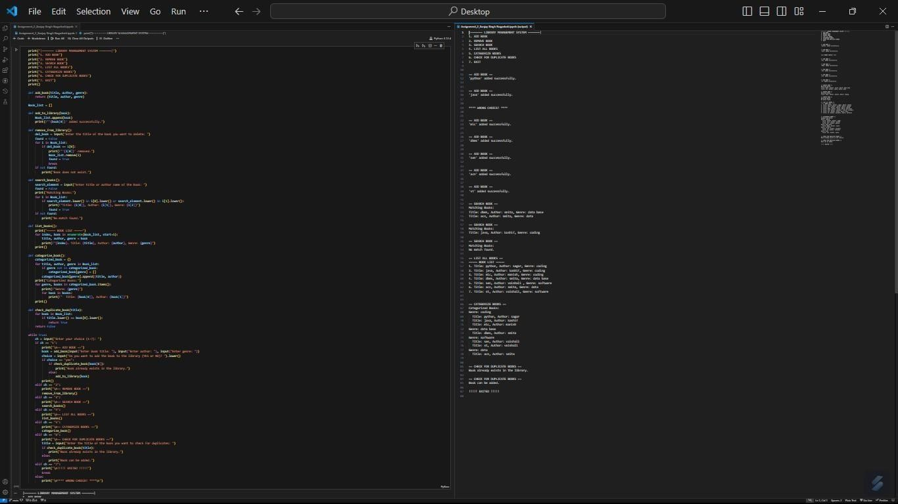

**Assignment 3. Vehicle Rental System**

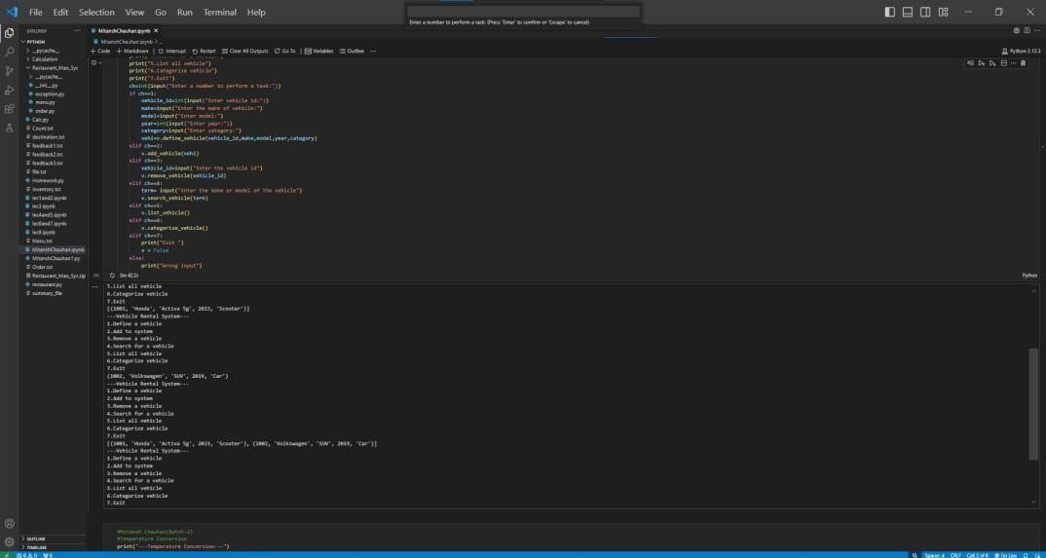

**Assignment 4: Feedback System using File Handling**

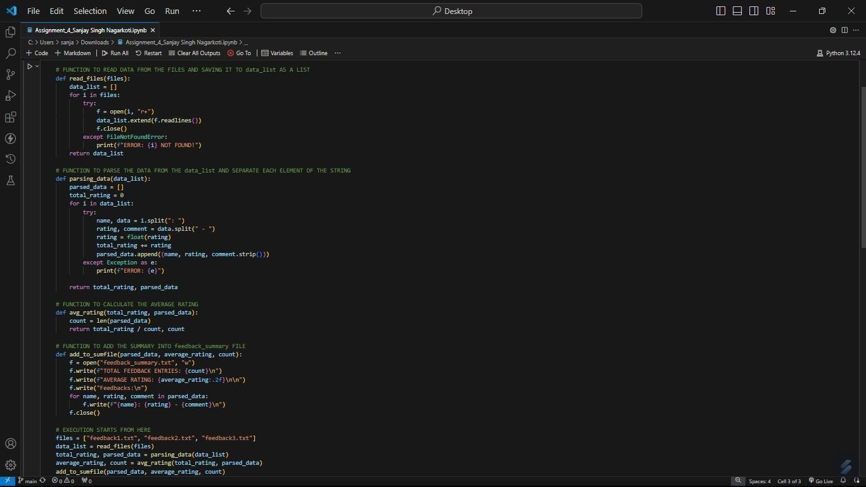

## Assignment 5: Inventory Management System

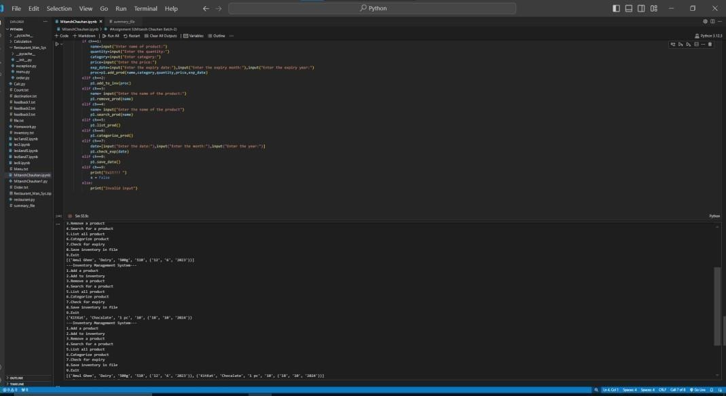

**Assignment 6: Restaurant Management System**

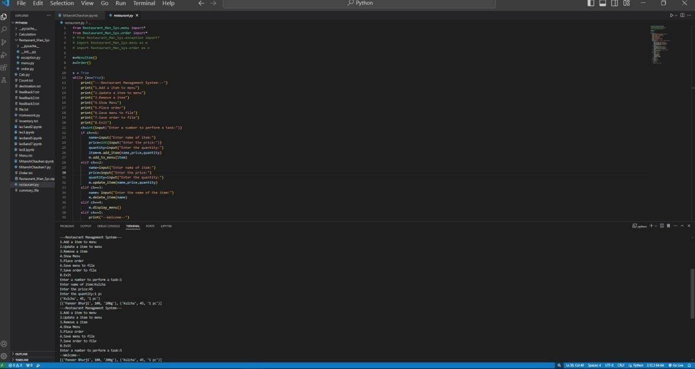

**Assignment 7: Data Cleaning and Analysis of COVID-19 Dataset**

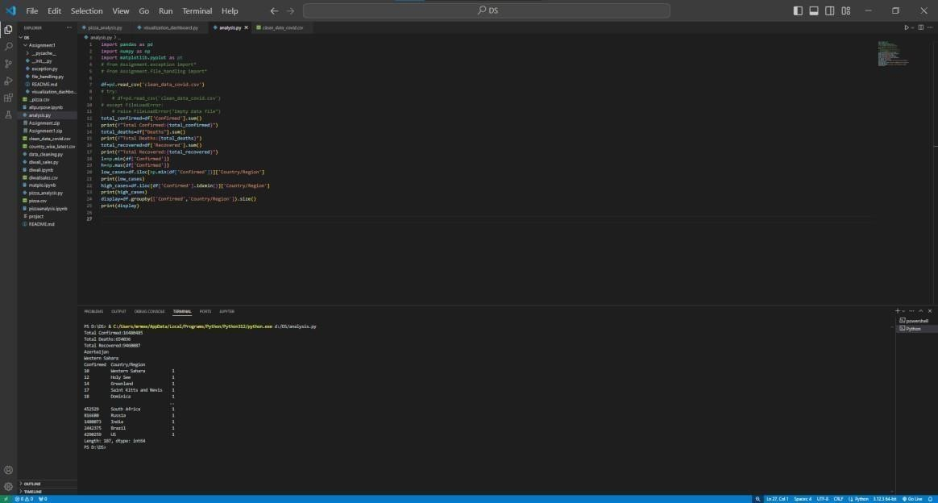

**Assignment 8: Data Visualization of COVID-19 Dataset**

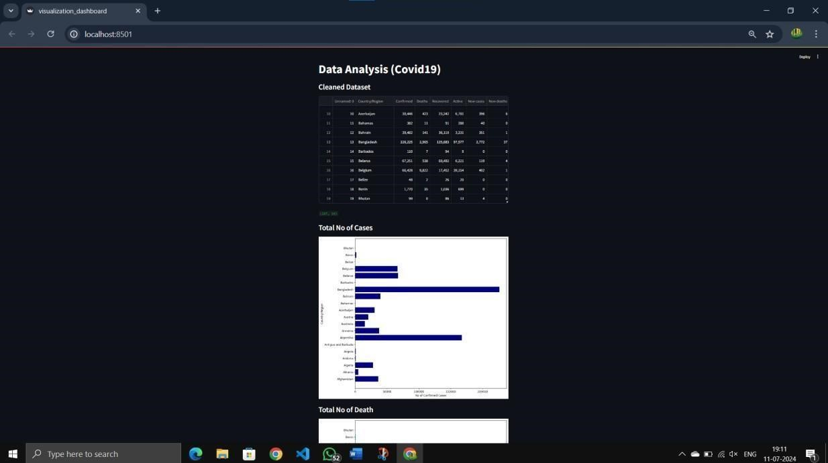

**JAVASCRIPT ASSIGNMENT**

**Assignment 1: Basic Concept of JavaScript**

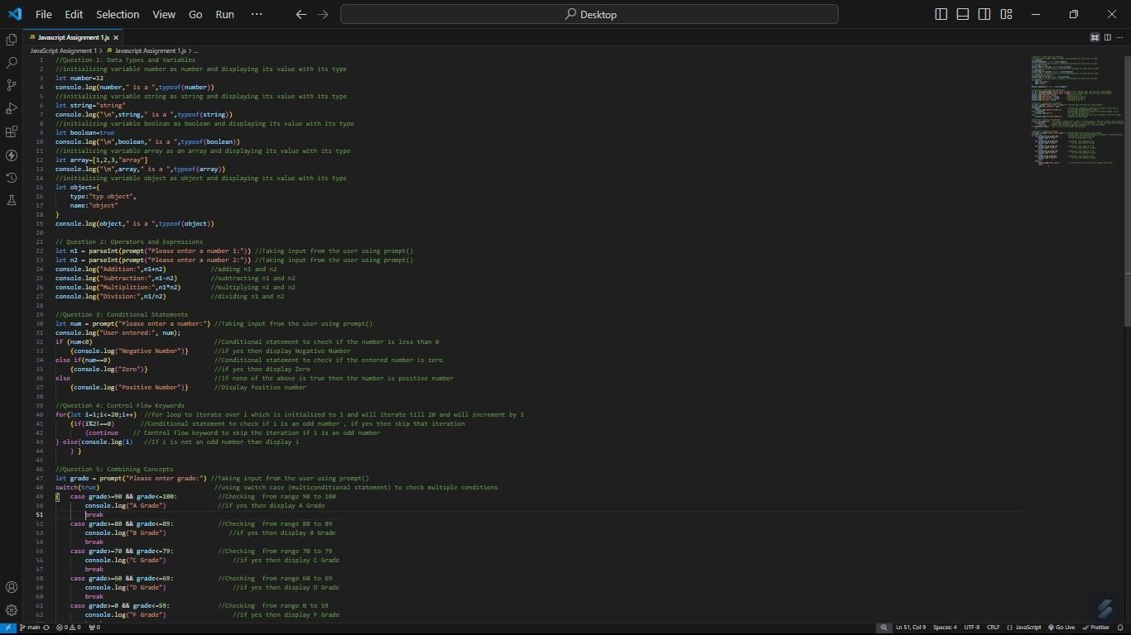

**Assignment 2**: **Implementation of Scope of Variables and Blocks**

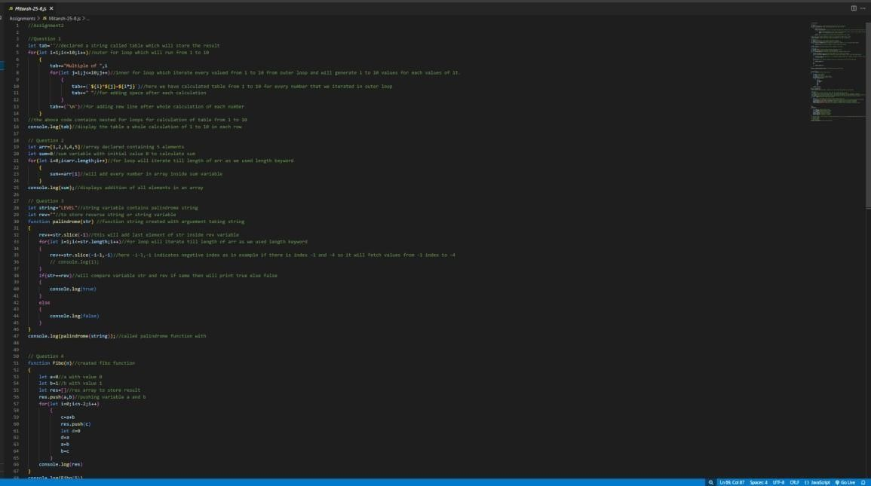

––

## Assignment 3: Array implementation and its method

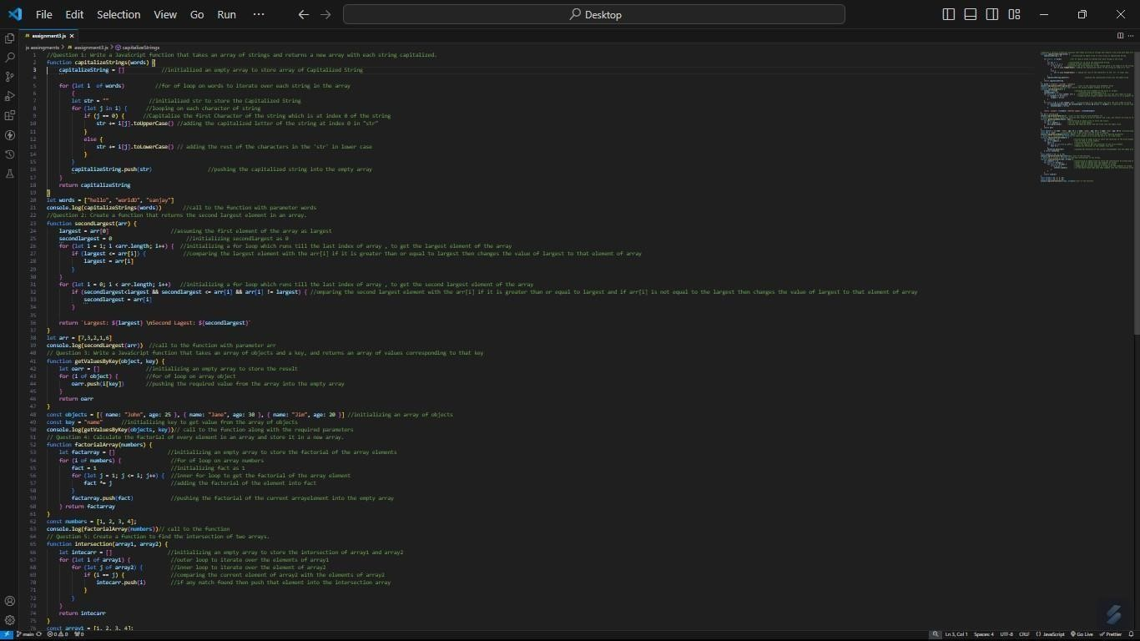

**Assignment 4**: **Implementation of Object and String methods**

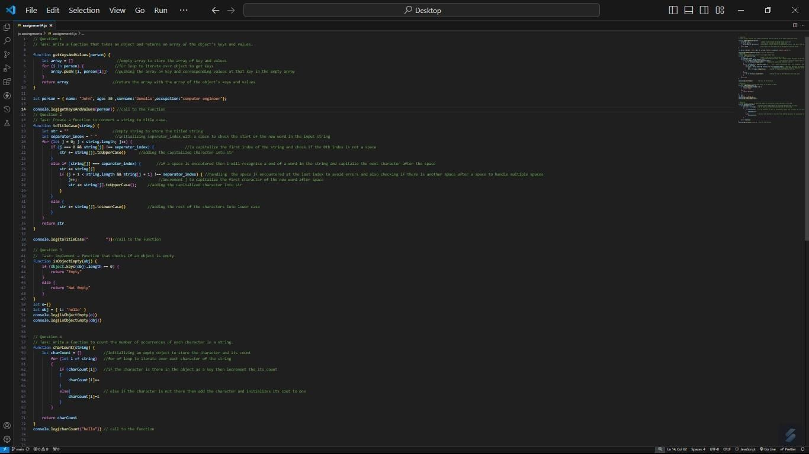

**Assignment 5: Implementation of Closure and Prototypes**

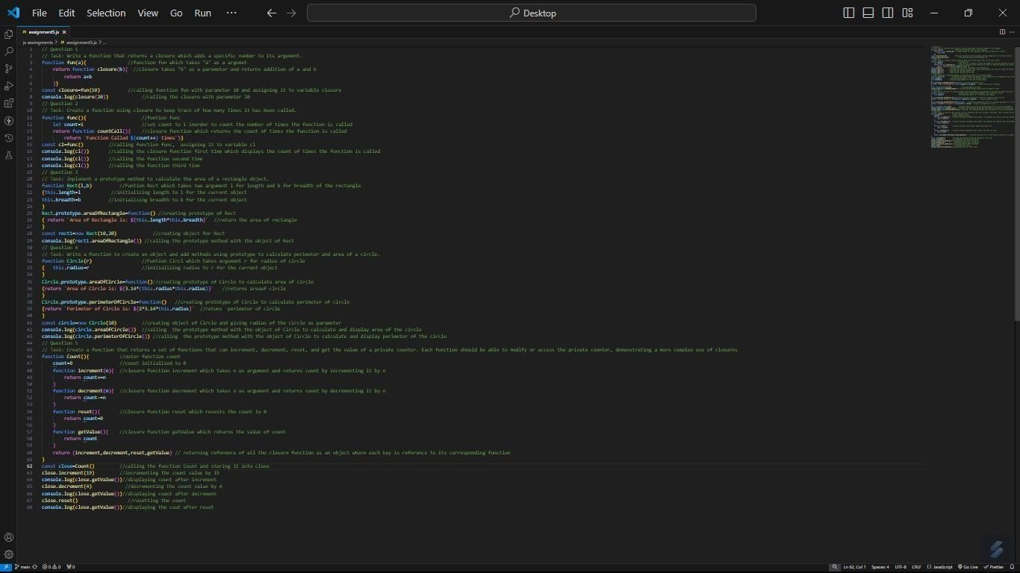

## NODE.JS ASSIGNMENTS

**Assignment 1**

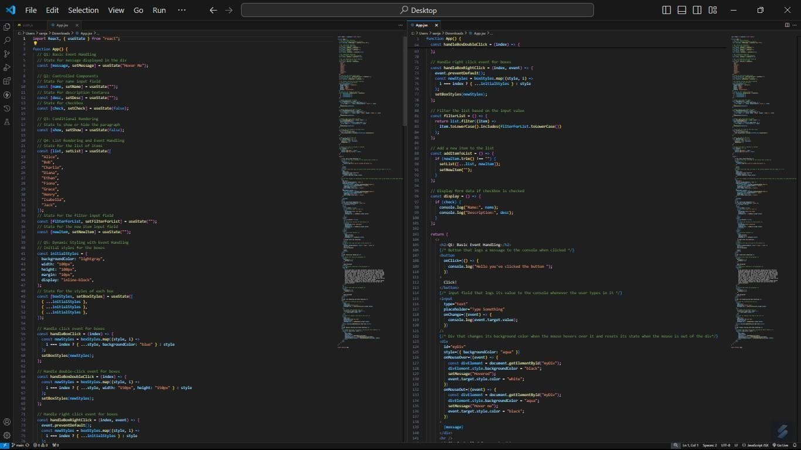

**Assignment 2.**

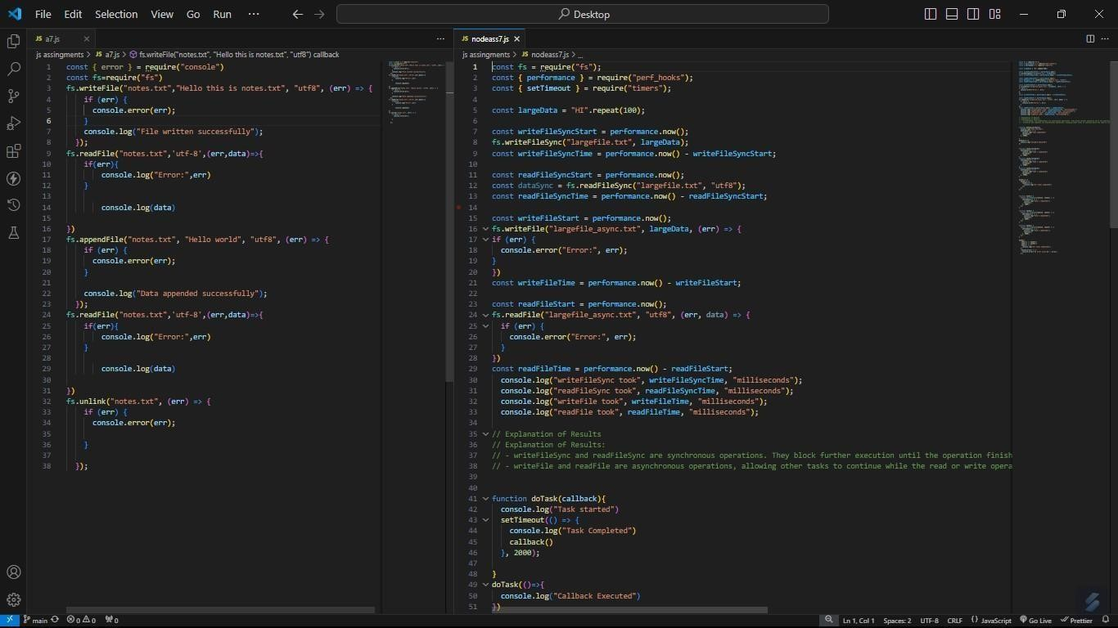

**Assignment 3.**

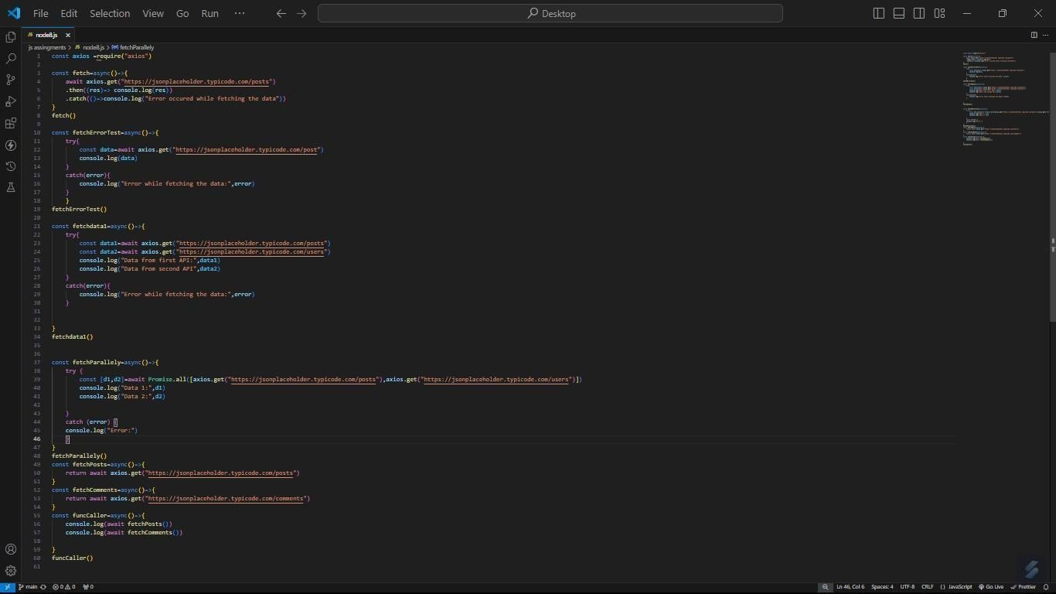

## React Assignments

**Assignment 1.**

Hello Prem

Hello Alice

Hello Bob

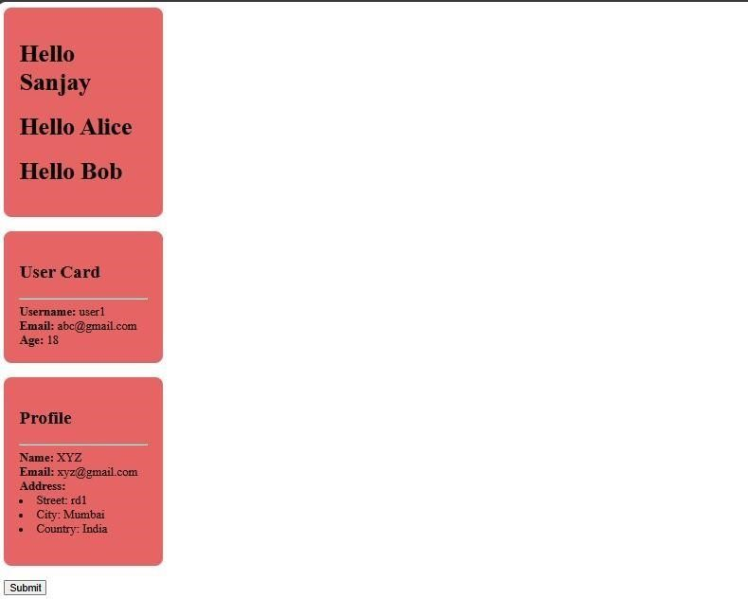

**Assignment 2.**

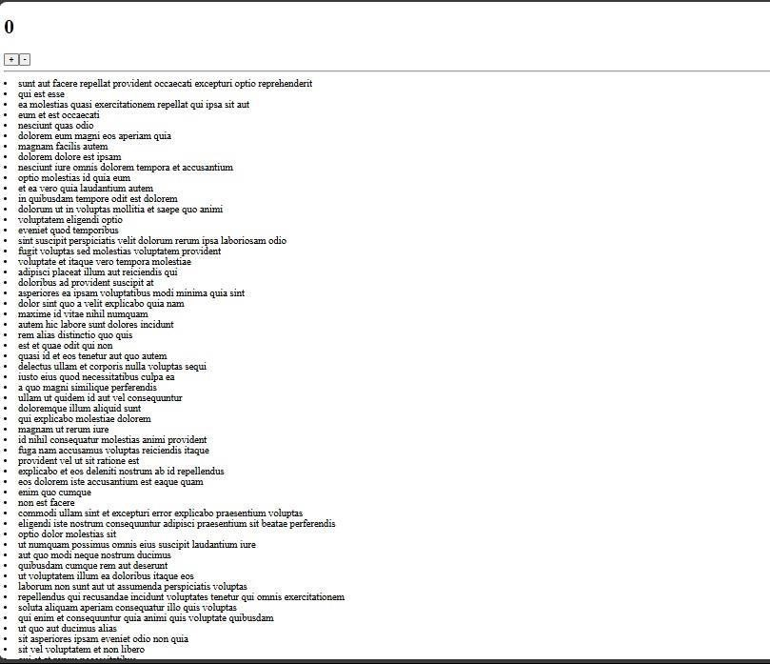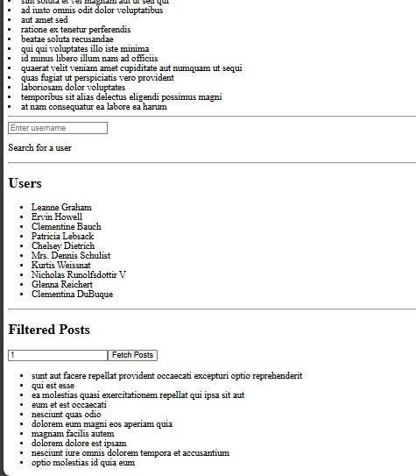

## SOFT SKILLS ASSIGNMENTS

**Assignment 1. Formal Email writing and E-signature Attach**

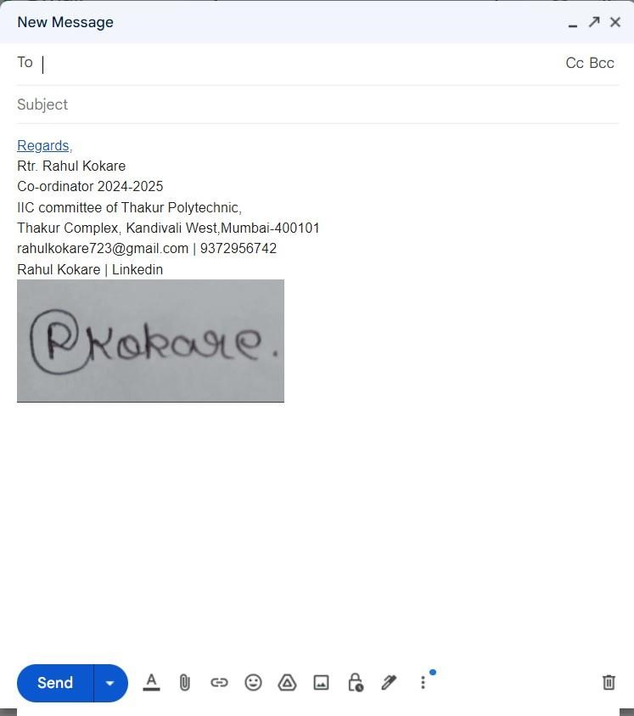

Regards,

Rtr.Prem Mane

TYCO-A 2024-2025

Thakur polytechnic,

Thakur complex, Kandivali(W) ,Mumbai 400 101

[Premmane542@gmail.com](mailto:Premmane542@gmail.com) ||9321679468



**Assignment 2. Resume Building (Google Docs)**

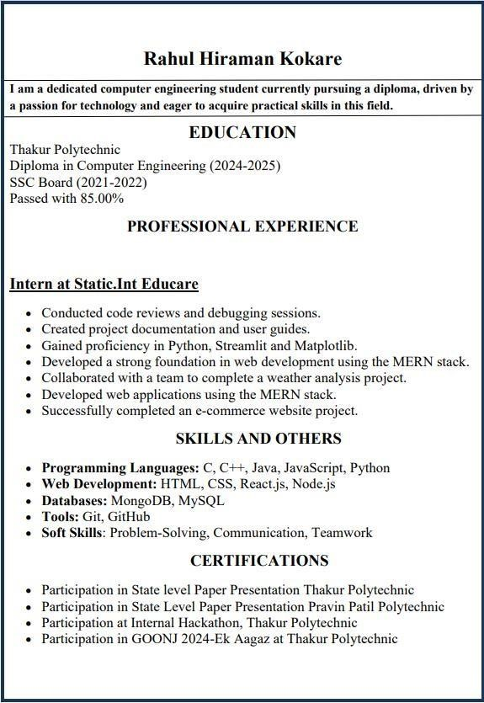

**Prem Rajendra Mane**

**Assignment 3. Resume Building (Canva)**

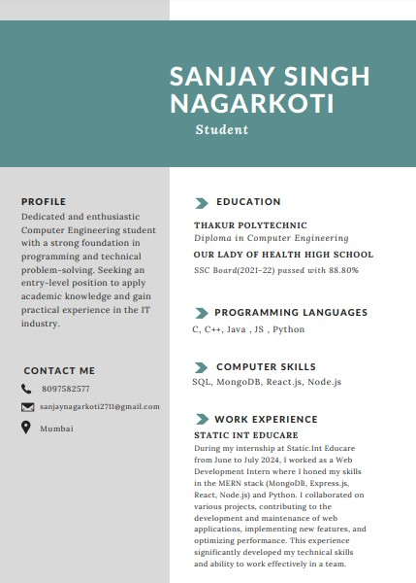

Premmane54@gmail.com

Prem Rajendra Mane

## Python Project :[Weather Analysis]

The weather analysis notebook demonstrates a simple analysis of a given weather dataset using Python. The dataset is a time-series dataset with per-hour information about the weather conditions at a particular location, including temperature, dew point temperature, relative humidity, wind speed, visibility, pressure, and weather description. The analysis involves loading the dataset, performing basic data analysis functions, and answering various data analysis problems.

1. **Data Loading**: The code loads a CSV file containing weather data into a Pandas Data Frame.
2. **Data Analysis**: The code performs basic data analysis, including checking for null values, duplicated values, and displaying the original dataset.
3. **Visualization**: The code generates four types of charts (bar, line, scatter, and pie) to visualize the weather data.
4. **User Interaction**: The code allows users to select a column from the dataset to visualize using a dropdown menu.
5. **Error Handling**: The code includes error handling for file not found, empty data, parsing errors, and general exceptions.

**Code Structure:**

The code is structured into the following sections:

1. **Importing Libraries**: The code imports the necessary libraries, including Pandas, Matplotlib, and Streamlit.
2. **Loading Data**: The code loads the CSV file into a Pandas Data Frame.
3. **Data Analysis**: The code performs basic data analysis, including checking for null values and duplicated values.
4. **Visualization**: The code generates four types of charts to visualize the weather data.
5. **User Interaction**: The code allows users to select a column from the dataset to visualize using a dropdown menu.
6. **Error Handling**: The code includes error handling for file not found, empty data, parsing errors, and general exceptions.

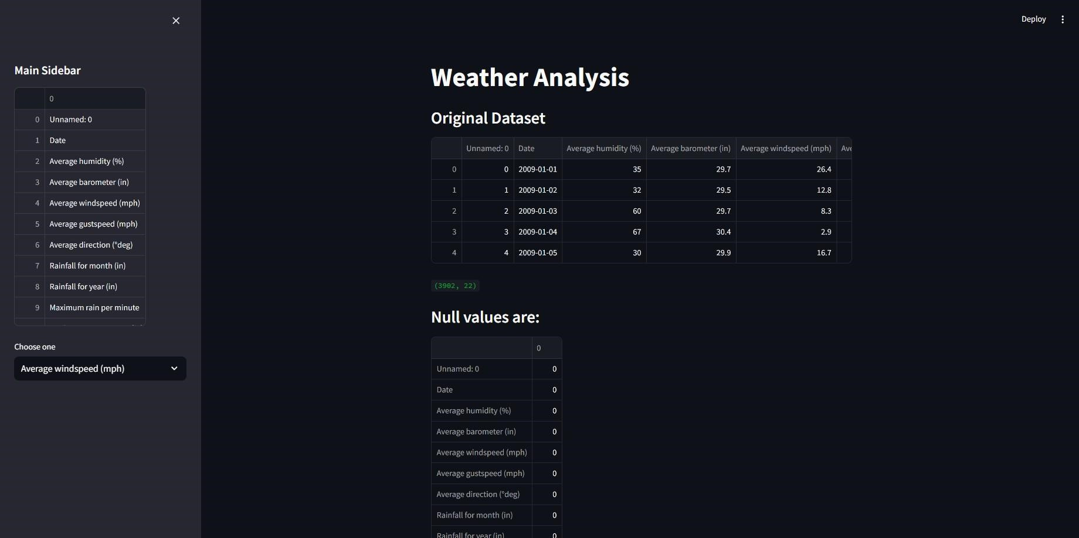

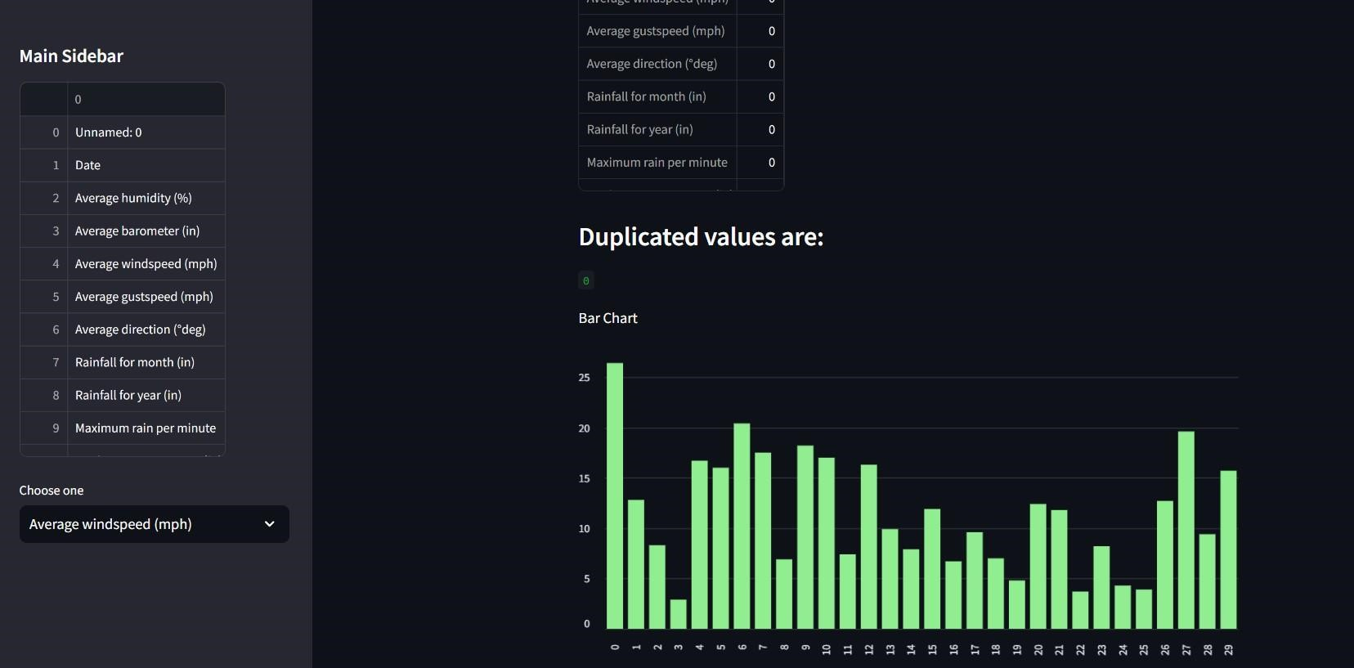

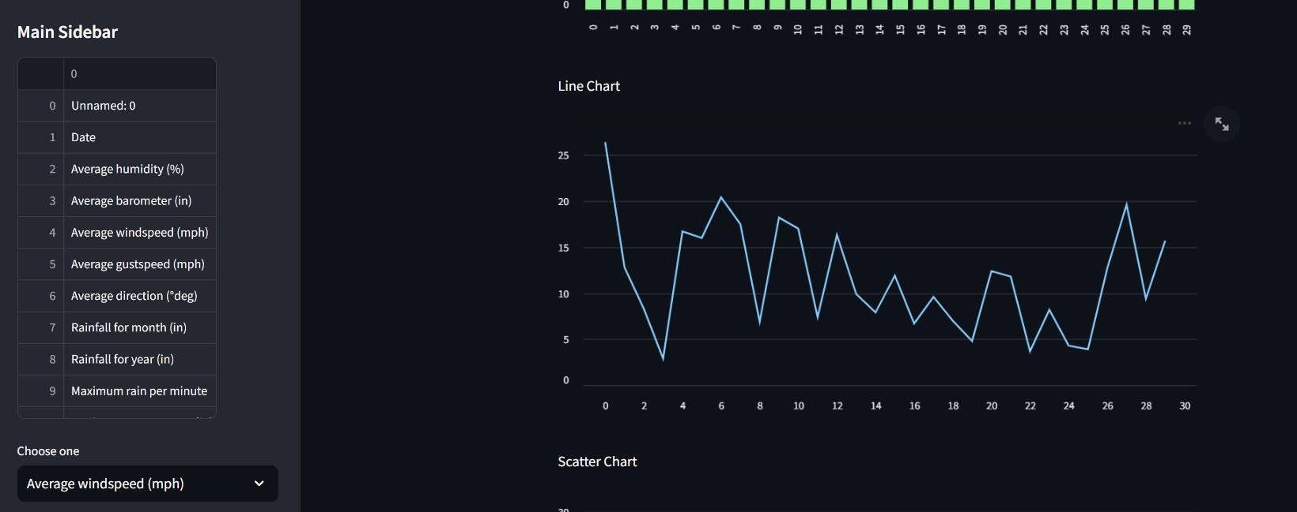

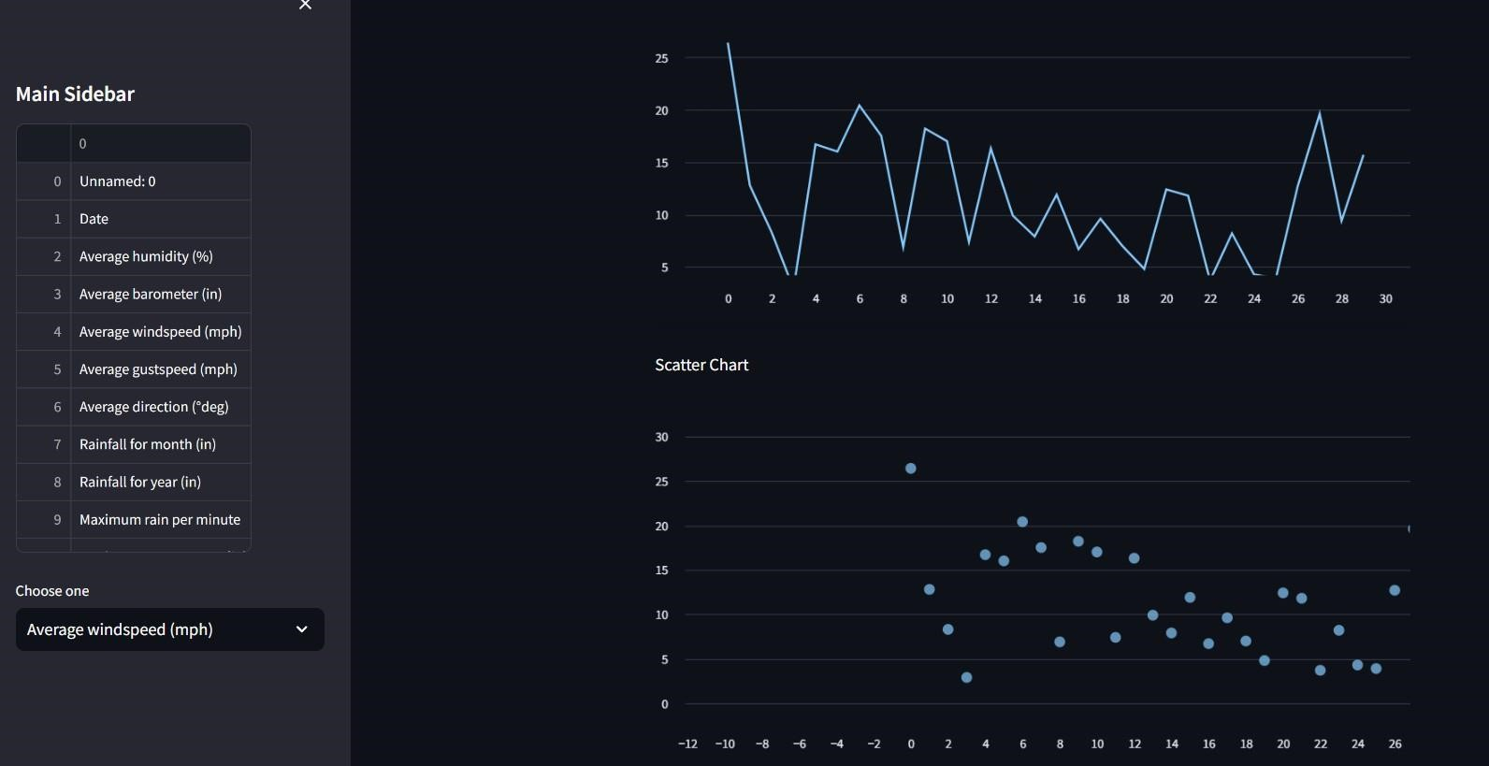

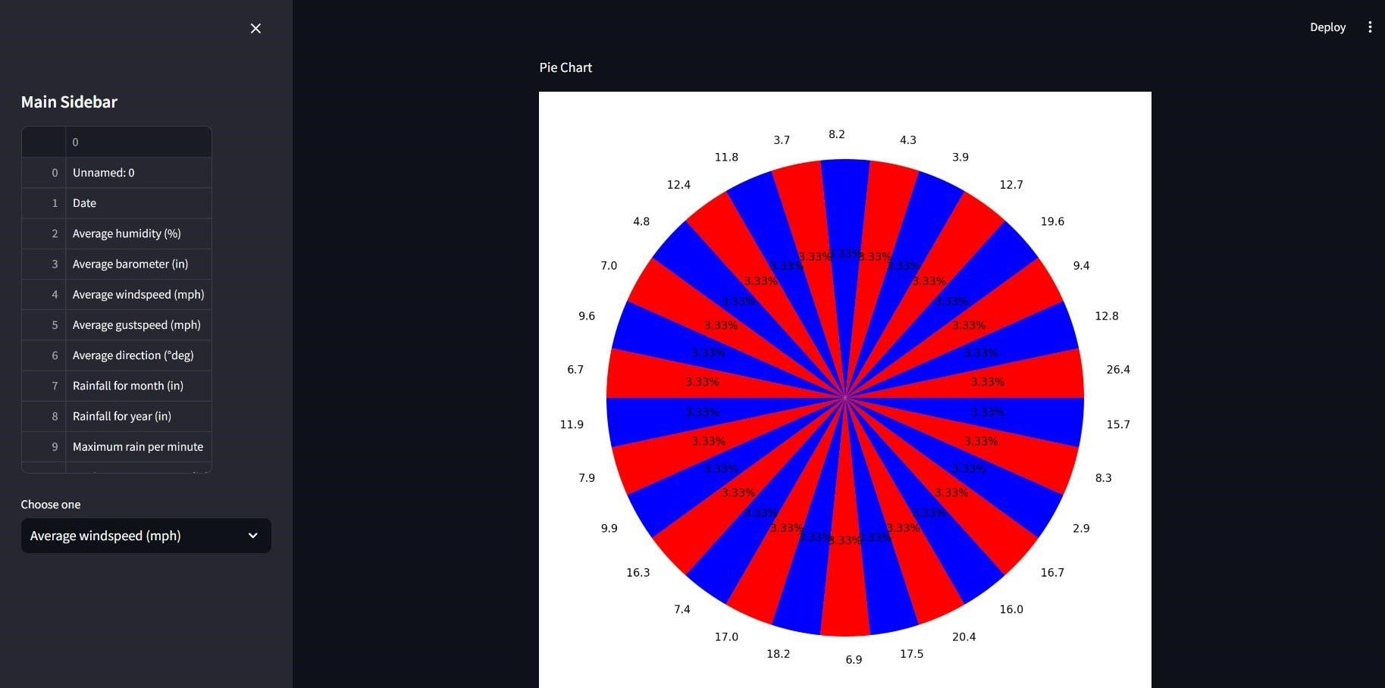

**React Project : Hospital Management**

The Hospital Management project in React is an open-source solution that aims to provide an affordable and efficient hospital management system for hospitals and around the world. The project was started by a team of developers who wanted to learn and give back to the developer community. The project has various modules that target the tasks each department in a hospital, including Records, Doctor, Laboratory, and Account. Some of these modules are completed, while others are still under development. The project uses React for the frontend and backend.The team is seeking more contributors to help with the development, testing, and documentation of the project.

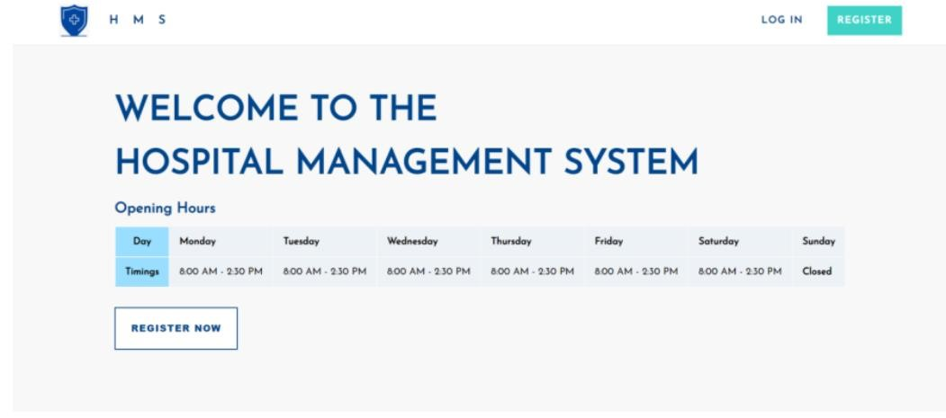

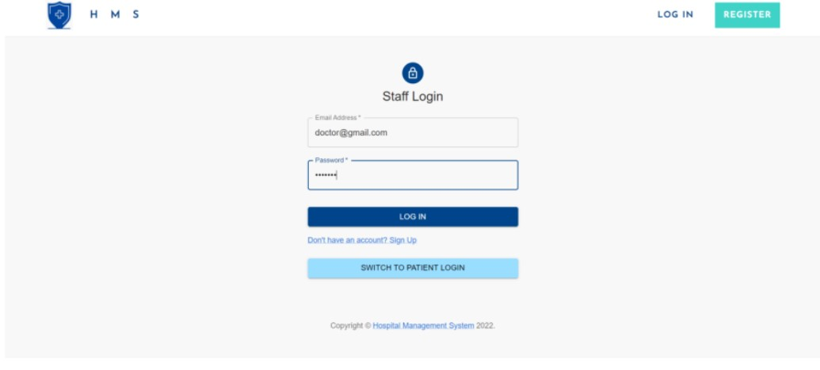

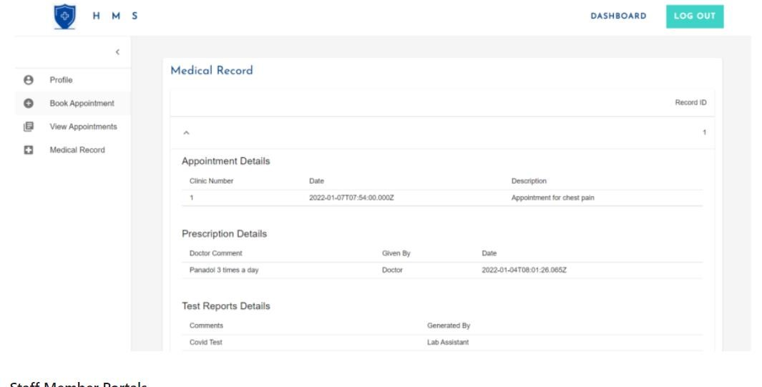

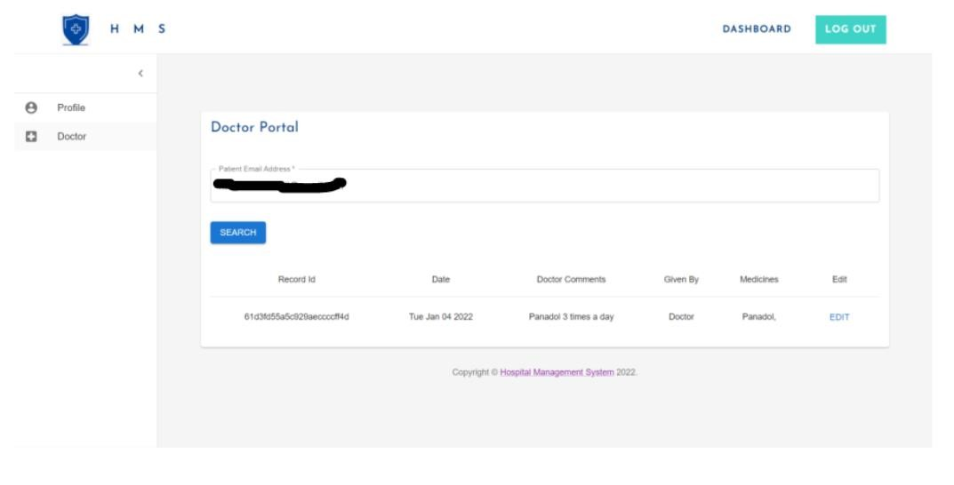

## Git Hub and Git Bash

1. **Introduction**

Today's professional development session focused on key aspects of software development, including Git, GitHub, and LinkedIn management. This report aims to provide an overview of the essential concepts covered during the session and the practical experiences gained.

1. **Version Control and Project Management with Git and GitHub**

The session commenced with a comprehensive exploration of version control and project management using Git and GitHub. We delved into the significance of version control in fostering collaboration, tracking changes, and maintaining an organized workflow. Through hands-on exercises, we familiarized ourselves with Git commands, branches, and repositories, empowering effective team collaboration.

1. **Enhancing Professional Presence on LinkedIn**

Another essential component of today's session was devoted to optimizing our professional presence on LinkedIn. Understanding the platform's importance in networking and building connections, we gained valuable insights into crafting compelling profiles. By emphasizing our skills, experiences, and aspirations, we learned how to leverage LinkedIn as a potent tool for career growth and industry

## Soft Skills

**Soft skills development** - self-introduction techniques, debate participation, presentation abilities, CV enhancement, and LinkedIn profile optimization.

**Key outcomes:**

* Mastered confident self-introduction and critical thinking in debates.
* Improved presentation skills for impactful delivery.
* Crafted impressive CVs to stand out in job applications.
* Optimized LinkedIn profiles for expanding professional networks.

**Expectations:**

Enhanced personal and professional growth through applied soft skills, fostering success in various scenarios.

# CHAPTER 10

**Special/Challenging experiences encountered during the training**

During the internship, we embarked on a journey of valuable learning experiences, encountering various challenges along the way. Our dedicated mentor played a crucial role in supporting us through these hurdles. They provided guidance and encouragement, empowering us to solve issues independently while offering helpful hints to steer us in the right direction. In the realm of React, we encountered occasional challenges related to the usage of state hooks and seamless component integration across files. The mentor's expertise and assistance proved invaluable in resolving these issues and ensuring smooth development. React is a popular JavaScript library for building use interfaces, particularly single-page applications, by enabling the development of scalable and high-performance web applications. JavaScript is a Dynamic, versatile programming language widely used for creating interactive and dynamic content on the web, from front-end user interfaces to server-side application.

Throughout the internship, our mentor's unwavering support and dedication helped us overcome obstacles and grow as developers. Their mentorship was a source of inspiration, and the lessons learned during this journey will undoubtedly shape our future endeavors in the world of programming.

# REFERENCES AND BIBLIOGRAPHY

* <http://www.staticinteducare.in/>
* https://platform.openai.com/docs/guides/gpt
* https://[www.weatherapi.com/](http://www.weatherapi.com/)
* https://react.dev/
* <https://docs.python.org/3/>
* <http://nodejs.org/docs/latest/api/>